Отчет по дисциплине

Основы информационной безопасности

Практика 3

Выполнил студент 2 курса группы БИСО-02-19

Москалев И С



|  |  |
| --- | --- |
| **create** | 2020-09-24T11:47:23+00:00 |
| ApertureValue | 200/100 |
| BitsPerSample | 8, 8, 8 |
| BrightnessValue | 0/1 |
| ColorSpace | 1 |
| ComponentsConfiguration | 1, 2, 3, 0 |
| Compression | 6 |
| Contrast | 0 |
| CustomRendered | 1 |
| DateTime | 2020:09:24 14:38:56 |
| DateTimeDigitized | 2020:09:24 14:38:56 |
| DateTimeOriginal | 2020:09:24 14:38:56 |
| DeviceSettingDescription | 105, 112, 112, 0 |
| DigitalZoomRatio | 100/100 |
| DocumentName |  |
| ExifImageLength | 3264 |
| ExifImageWidth | 2448 |
| ExifOffset | 288 |
| ExifVersion | 48, 50, 49, 48 |
| ExposureBiasValue | 0/10 |
| ExposureMode | 0 |
| ExposureProgram | 2 |
| ExposureTime | 50000000/1000000000 |
| FileSource | 3 |
| Flash | 24 |
| FlashPixVersion | 48, 49, 48, 48 |
| FNumber | 200/100 |
| FocalLength | 2840/1000 |
| FocalLengthIn35mmFilm | 27 |
| GainControl | 0 |
| GPSAltitude | 15890/100 |
| GPSAltitudeRef | 0 |
| GPSDateStamp | 2020:09:24 |
| GPSInfo | 8462 |
| GPSLatitude | 55/1, 47/1, 37241821/1000000 |
| GPSLatitudeRef | N |
| GPSLongitude | 37/1, 42/1, 5729370/1000000 |
| GPSLongitudeRef | E |
| GPSProcessingMethod | CELLID |
| GPSTimeStamp | 11/1, 38/1, 55/1 |
| GPSVersionID | 2, 2, 0, 0 |
| ImageDescription | fbt |
| ImageLength | 3264 |
| ImageWidth | 2448 |
| InteroperabilityIndex | R98 |
| InteroperabilityOffset | 8432 |
| InteroperabilityVersion | 48, 49, 48, 48 |
| ISOSpeedRatings | 160 |
| JPEGInterchangeFormat | 8818 |
| JPEGInterchangeFormatLength | 19862 |
| LightSource | 1 |
| Make | HUAWEI |
| MakerNote | 35, 35, 35, 35, 10, 0, 0, 0, 26, 199, 51, 1, 0, 2, 1, 0, 0, 0, 0, 0, 0, 0, 0, 0, 0, 0, 0, 0, 0, 0, 0, 0, 175, 0, 0, 0, 255, 255, 255, 255, 255, 255, 255, 255, 255, 255, 255, 255, 255, 255, 255, 255, 255, 255, 255, 255, 255, 255, 255, 255, 255, 255, 255, 255, 255, 255, 255, 255, 255, 255, 255, 255, 255, 255, 255, 255, 255, 255, 255, 255, 255, 255, 255, 255, 255, 255, 255, 255, 255, 255, 255, 255, 255, 255, 255, 255, 255, 255, 255, 255 |
| MeteringMode | 5 |
| Model | WAS-LX1 |
| Orientation | 0 |
| ResolutionUnit | 2 |
| Saturation | 0 |
| SceneCaptureType | 0 |
| SceneType | 1 |
| SensingMethod | 2 |
| Sharpness | 0 |
| ShutterSpeedValue | 298973/10000 |
| Software | WAS-LX1 8.0.0.394(C10) |
| SubjectDistanceRange | 0 |
| SubSecTime | 720156 |
| SubSecTimeDigitized | 720156 |
| SubSecTimeOriginal | 720156 |
| WhiteBalance | 0 |
| XResolution | 72/1 |
| YCbCrPositioning | 1 |
| YResolution | 72/1 |
| **modify** | 2020-09-24T11:47:23+00:00 |
| ApertureValue | 200/100 |
| BitsPerSample | 8, 8, 8 |
| BrightnessValue | 0/1 |
| ColorSpace | 1 |
| ComponentsConfiguration | 1, 2, 3, 0 |
| Compression | 6 |
| Contrast | 0 |
| CustomRendered | 1 |
| DateTime | 2020:09:24 14:38:56 |
| DateTimeDigitized | 2020:09:24 14:38:56 |
| DateTimeOriginal | 2020:09:24 14:38:56 |
| DeviceSettingDescription | 105, 112, 112, 0 |
| DigitalZoomRatio | 100/100 |
| DocumentName |  |
| ExifImageLength | 3264 |
| ExifImageWidth | 2448 |
| ExifOffset | 288 |
| ExifVersion | 48, 50, 49, 48 |
| ExposureBiasValue | 0/10 |
| ExposureMode | 0 |
| ExposureProgram | 2 |
| ExposureTime | 50000000/1000000000 |
| FileSource | 3 |
| Flash | 24 |
| FlashPixVersion | 48, 49, 48, 48 |
| FNumber | 200/100 |
| FocalLength | 2840/1000 |
| FocalLengthIn35mmFilm | 27 |
| GainControl | 0 |
| GPSAltitude | 15890/100 |
| GPSAltitudeRef | 0 |
| GPSDateStamp | 2020:09:24 |
| GPSInfo | 8462 |
| GPSLatitude | 55/1, 47/1, 37241821/1000000 |
| GPSLatitudeRef | N |
| GPSLongitude | 37/1, 42/1, 5729370/1000000 |
| GPSLongitudeRef | E |
| GPSProcessingMethod | CELLID |
| GPSTimeStamp | 11/1, 38/1, 55/1 |
| GPSVersionID | 2, 2, 0, 0 |
| ImageDescription | fbt |
| ImageLength | 3264 |
| ImageWidth | 2448 |
| InteroperabilityIndex | R98 |
| InteroperabilityOffset | 8432 |
| InteroperabilityVersion | 48, 49, 48, 48 |
| ISOSpeedRatings | 160 |
| JPEGInterchangeFormat | 8818 |
| JPEGInterchangeFormatLength | 19862 |
| LightSource | 1 |
| Make | HUAWEI |
| MakerNote | 35, 35, 35, 35, 10, 0, 0, 0, 26, 199, 51, 1, 0, 2, 1, 0, 0, 0, 0, 0, 0, 0, 0, 0, 0, 0, 0, 0, 0, 0, 0, 0, 175, 0, 0, 0, 255, 255, 255, 255, 255, 255, 255, 255, 255, 255, 255, 255, 255, 255, 255, 255, 255, 255, 255, 255, 255, 255, 255, 255, 255, 255, 255, 255, 255, 255, 255, 255, 255, 255, 255, 255, 255, 255, 255, 255, 255, 255, 255, 255, 255, 255, 255, 255, 255, 255, 255, 255, 255, 255, 255, 255, 255, 255, 255, 255, 255, 255, 255, 255 |
| MeteringMode | 5 |
| Model | WAS-LX1 |
| Orientation | 0 |
| ResolutionUnit | 2 |
| Saturation | 0 |
| SceneCaptureType | 0 |
| SceneType | 1 |
| SensingMethod | 2 |
| Sharpness | 0 |
| ShutterSpeedValue | 298973/10000 |
| Software | WAS-LX1 8.0.0.394(C10) |
| SubjectDistanceRange | 0 |
| SubSecTime | 720156 |
| SubSecTimeDigitized | 720156 |
| SubSecTimeOriginal | 720156 |
| WhiteBalance | 0 |
| XResolution | 72/1 |
| YCbCrPositioning | 1 |
| YResolution | 72/1 |
| **colorspace** | 2 |
| ApertureValue | 200/100 |
| BitsPerSample | 8, 8, 8 |
| BrightnessValue | 0/1 |
| ColorSpace | 1 |
| ComponentsConfiguration | 1, 2, 3, 0 |
| Compression | 6 |
| Contrast | 0 |
| CustomRendered | 1 |
| DateTime | 2020:09:24 14:38:56 |
| DateTimeDigitized | 2020:09:24 14:38:56 |
| DateTimeOriginal | 2020:09:24 14:38:56 |
| DeviceSettingDescription | 105, 112, 112, 0 |
| DigitalZoomRatio | 100/100 |
| DocumentName |  |
| ExifImageLength | 3264 |
| ExifImageWidth | 2448 |
| ExifOffset | 288 |
| ExifVersion | 48, 50, 49, 48 |
| ExposureBiasValue | 0/10 |
| ExposureMode | 0 |
| ExposureProgram | 2 |
| ExposureTime | 50000000/1000000000 |
| FileSource | 3 |
| Flash | 24 |
| FlashPixVersion | 48, 49, 48, 48 |
| FNumber | 200/100 |
| FocalLength | 2840/1000 |
| FocalLengthIn35mmFilm | 27 |
| GainControl | 0 |
| GPSAltitude | 15890/100 |
| GPSAltitudeRef | 0 |
| GPSDateStamp | 2020:09:24 |
| GPSInfo | 8462 |
| GPSLatitude | 55/1, 47/1, 37241821/1000000 |
| GPSLatitudeRef | N |
| GPSLongitude | 37/1, 42/1, 5729370/1000000 |
| GPSLongitudeRef | E |
| GPSProcessingMethod | CELLID |
| GPSTimeStamp | 11/1, 38/1, 55/1 |
| GPSVersionID | 2, 2, 0, 0 |
| ImageDescription | fbt |
| ImageLength | 3264 |
| ImageWidth | 2448 |
| InteroperabilityIndex | R98 |
| InteroperabilityOffset | 8432 |
| InteroperabilityVersion | 48, 49, 48, 48 |
| ISOSpeedRatings | 160 |
| JPEGInterchangeFormat | 8818 |
| JPEGInterchangeFormatLength | 19862 |
| LightSource | 1 |
| Make | HUAWEI |
| MakerNote | 35, 35, 35, 35, 10, 0, 0, 0, 26, 199, 51, 1, 0, 2, 1, 0, 0, 0, 0, 0, 0, 0, 0, 0, 0, 0, 0, 0, 0, 0, 0, 0, 175, 0, 0, 0, 255, 255, 255, 255, 255, 255, 255, 255, 255, 255, 255, 255, 255, 255, 255, 255, 255, 255, 255, 255, 255, 255, 255, 255, 255, 255, 255, 255, 255, 255, 255, 255, 255, 255, 255, 255, 255, 255, 255, 255, 255, 255, 255, 255, 255, 255, 255, 255, 255, 255, 255, 255, 255, 255, 255, 255, 255, 255, 255, 255, 255, 255, 255, 255 |
| MeteringMode | 5 |
| Model | WAS-LX1 |
| Orientation | 0 |
| ResolutionUnit | 2 |
| Saturation | 0 |
| SceneCaptureType | 0 |
| SceneType | 1 |
| SensingMethod | 2 |
| Sharpness | 0 |
| ShutterSpeedValue | 298973/10000 |
| Software | WAS-LX1 8.0.0.394(C10) |
| SubjectDistanceRange | 0 |
| SubSecTime | 720156 |
| SubSecTimeDigitized | 720156 |
| SubSecTimeOriginal | 720156 |
| WhiteBalance | 0 |
| XResolution | 72/1 |
| YCbCrPositioning | 1 |
| YResolution | 72/1 |
| **sampling-factor** | 2x2,1x1,1x1 |
| ApertureValue | 200/100 |
| BitsPerSample | 8, 8, 8 |
| BrightnessValue | 0/1 |
| ColorSpace | 1 |
| ComponentsConfiguration | 1, 2, 3, 0 |
| Compression | 6 |
| Contrast | 0 |
| CustomRendered | 1 |
| DateTime | 2020:09:24 14:38:56 |
| DateTimeDigitized | 2020:09:24 14:38:56 |
| DateTimeOriginal | 2020:09:24 14:38:56 |
| DeviceSettingDescription | 105, 112, 112, 0 |
| DigitalZoomRatio | 100/100 |
| DocumentName |  |
| ExifImageLength | 3264 |
| ExifImageWidth | 2448 |
| ExifOffset | 288 |
| ExifVersion | 48, 50, 49, 48 |
| ExposureBiasValue | 0/10 |
| ExposureMode | 0 |
| ExposureProgram | 2 |
| ExposureTime | 50000000/1000000000 |
| FileSource | 3 |
| Flash | 24 |
| FlashPixVersion | 48, 49, 48, 48 |
| FNumber | 200/100 |
| FocalLength | 2840/1000 |
| FocalLengthIn35mmFilm | 27 |
| GainControl | 0 |
| GPSAltitude | 15890/100 |
| GPSAltitudeRef | 0 |
| GPSDateStamp | 2020:09:24 |
| GPSInfo | 8462 |
| GPSLatitude | 55/1, 47/1, 37241821/1000000 |
| GPSLatitudeRef | N |
| GPSLongitude | 37/1, 42/1, 5729370/1000000 |
| GPSLongitudeRef | E |
| GPSProcessingMethod | CELLID |
| GPSTimeStamp | 11/1, 38/1, 55/1 |
| GPSVersionID | 2, 2, 0, 0 |
| ImageDescription | fbt |
| ImageLength | 3264 |
| ImageWidth | 2448 |
| InteroperabilityIndex | R98 |
| InteroperabilityOffset | 8432 |
| InteroperabilityVersion | 48, 49, 48, 48 |
| ISOSpeedRatings | 160 |
| JPEGInterchangeFormat | 8818 |
| JPEGInterchangeFormatLength | 19862 |
| LightSource | 1 |
| Make | HUAWEI |
| MakerNote | 35, 35, 35, 35, 10, 0, 0, 0, 26, 199, 51, 1, 0, 2, 1, 0, 0, 0, 0, 0, 0, 0, 0, 0, 0, 0, 0, 0, 0, 0, 0, 0, 175, 0, 0, 0, 255, 255, 255, 255, 255, 255, 255, 255, 255, 255, 255, 255, 255, 255, 255, 255, 255, 255, 255, 255, 255, 255, 255, 255, 255, 255, 255, 255, 255, 255, 255, 255, 255, 255, 255, 255, 255, 255, 255, 255, 255, 255, 255, 255, 255, 255, 255, 255, 255, 255, 255, 255, 255, 255, 255, 255, 255, 255, 255, 255, 255, 255, 255, 255 |
| MeteringMode | 5 |
| Model | WAS-LX1 |
| Orientation | 0 |
| ResolutionUnit | 2 |
| Saturation | 0 |
| SceneCaptureType | 0 |
| SceneType | 1 |
| SensingMethod | 2 |
| Sharpness | 0 |
| ShutterSpeedValue | 298973/10000 |
| Software | WAS-LX1 8.0.0.394(C10) |
| SubjectDistanceRange | 0 |
| SubSecTime | 720156 |
| SubSecTimeDigitized | 720156 |
| SubSecTimeOriginal | 720156 |
| WhiteBalance | 0 |
| XResolution | 72/1 |
| YCbCrPositioning | 1 |
| YResolution | 72/1 |

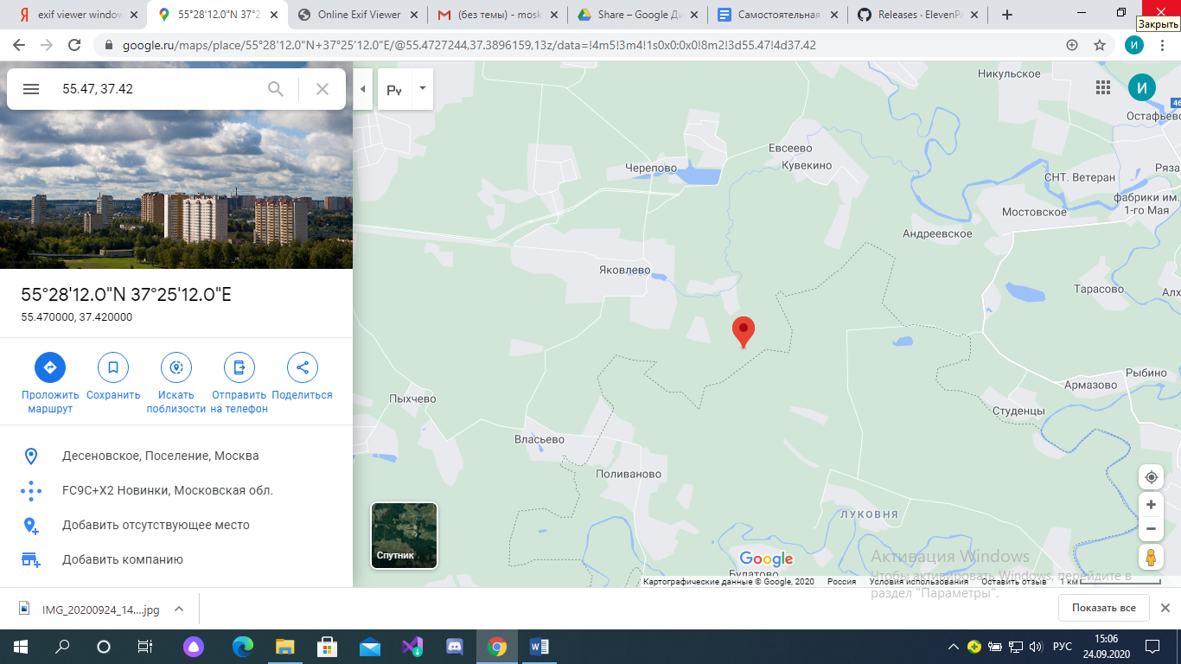Мое местоположение :



Работа с программой FOCA

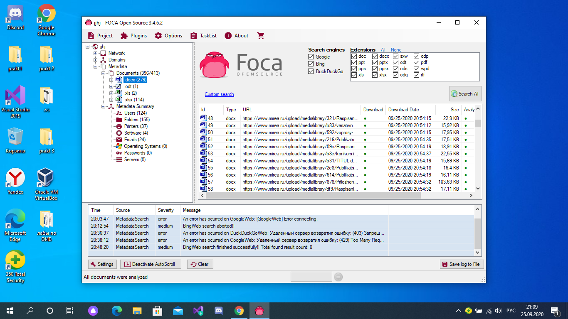

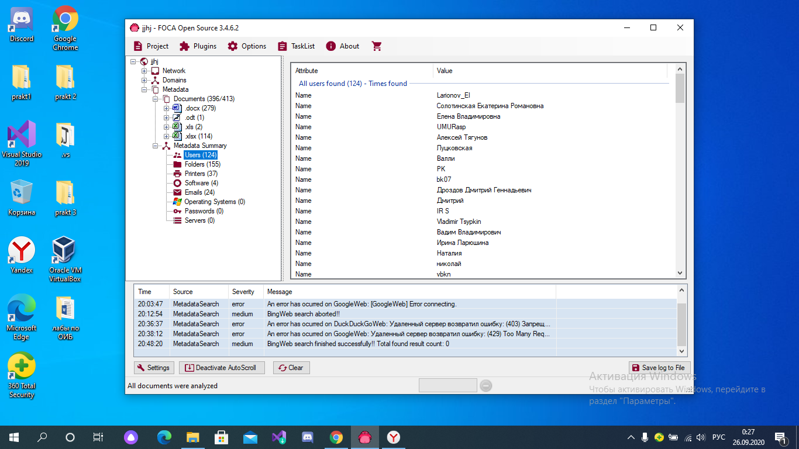

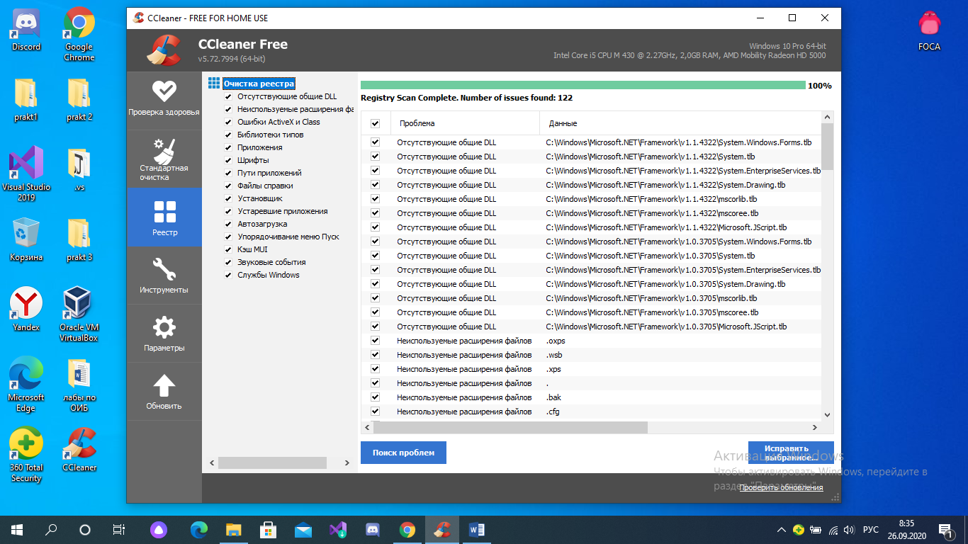

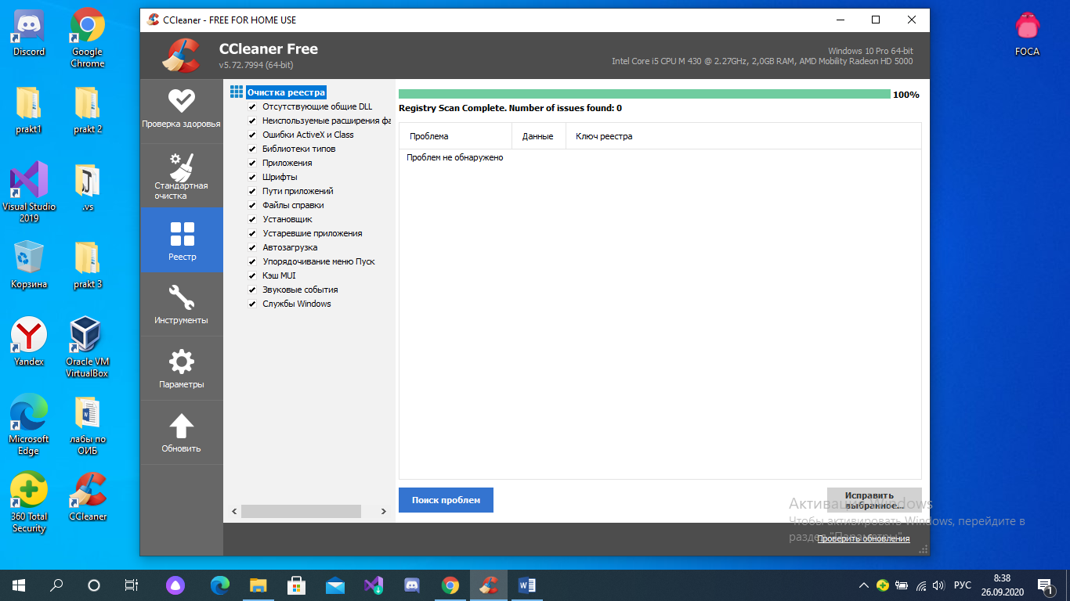

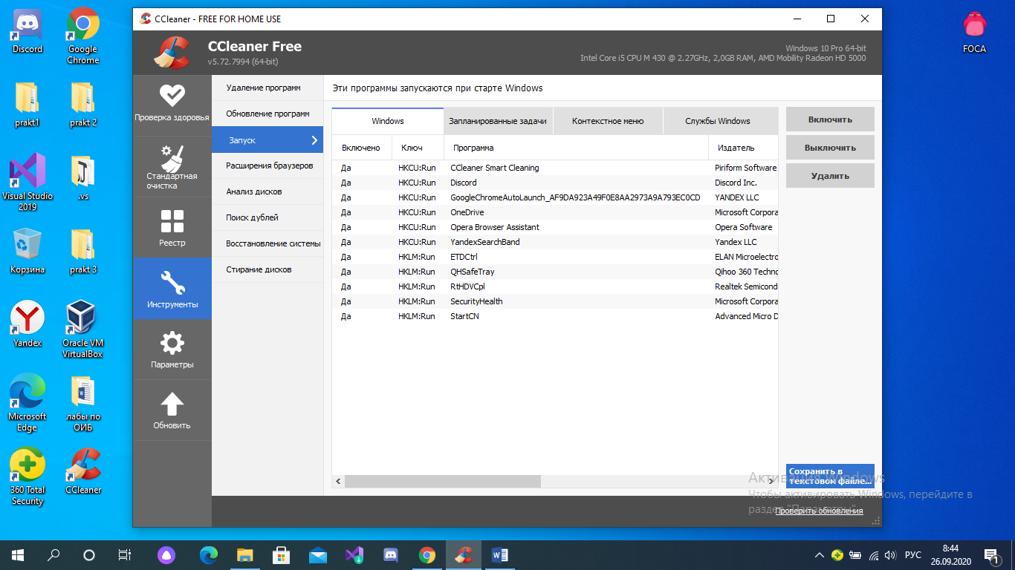

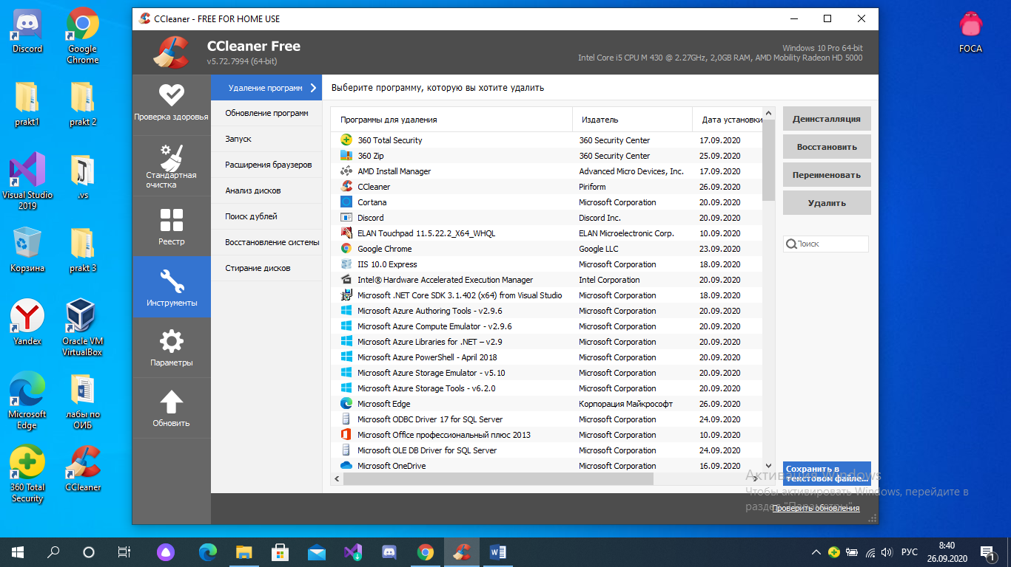

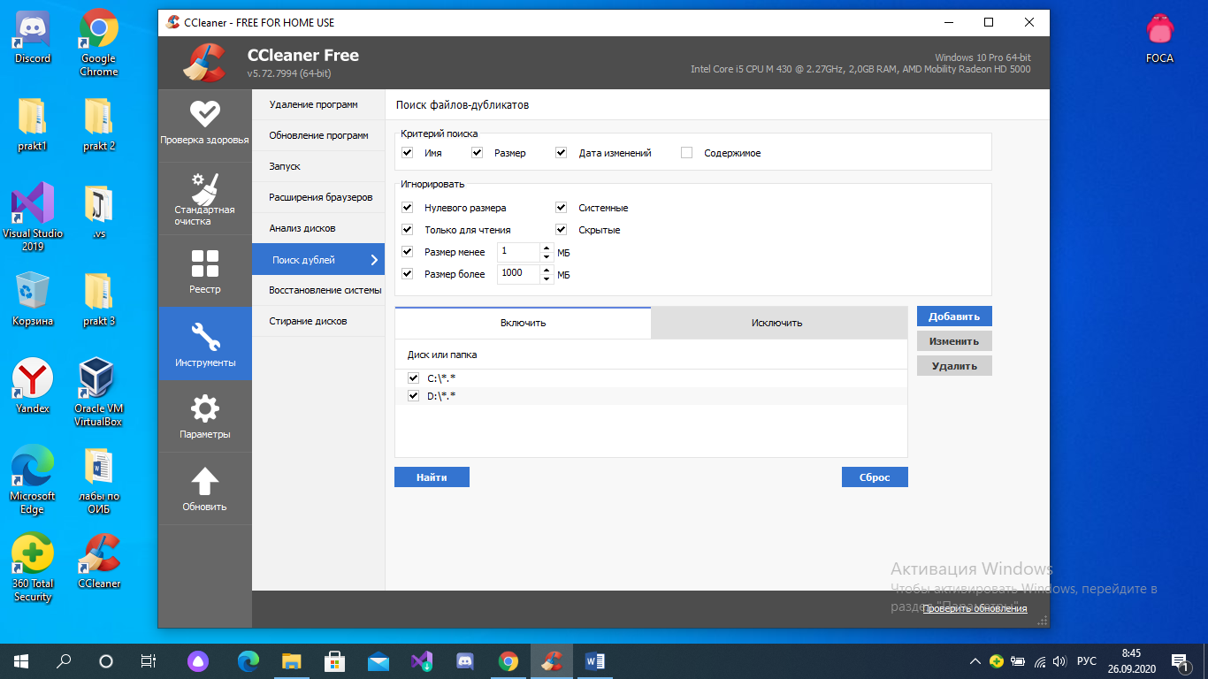

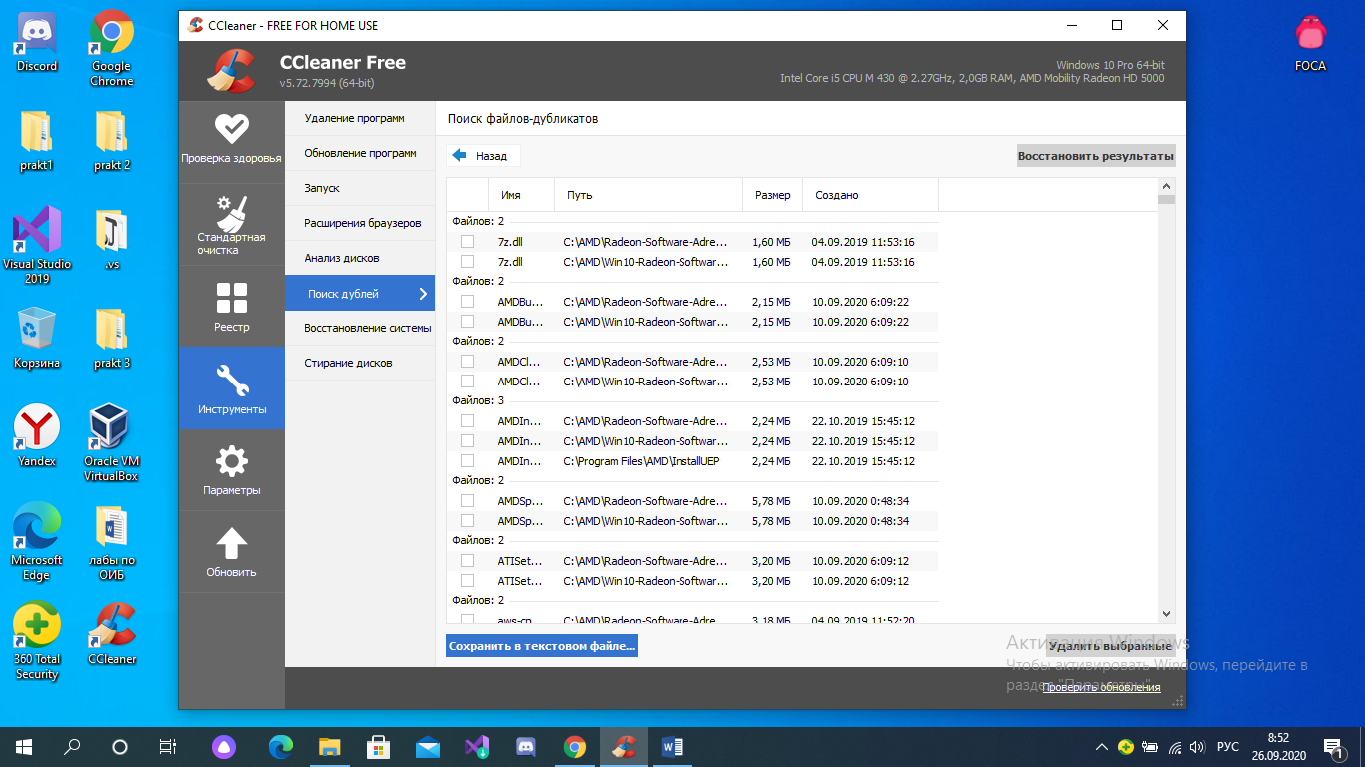

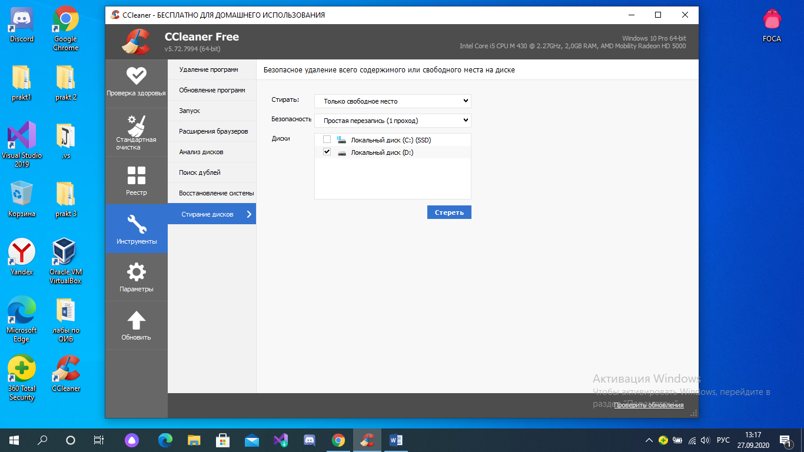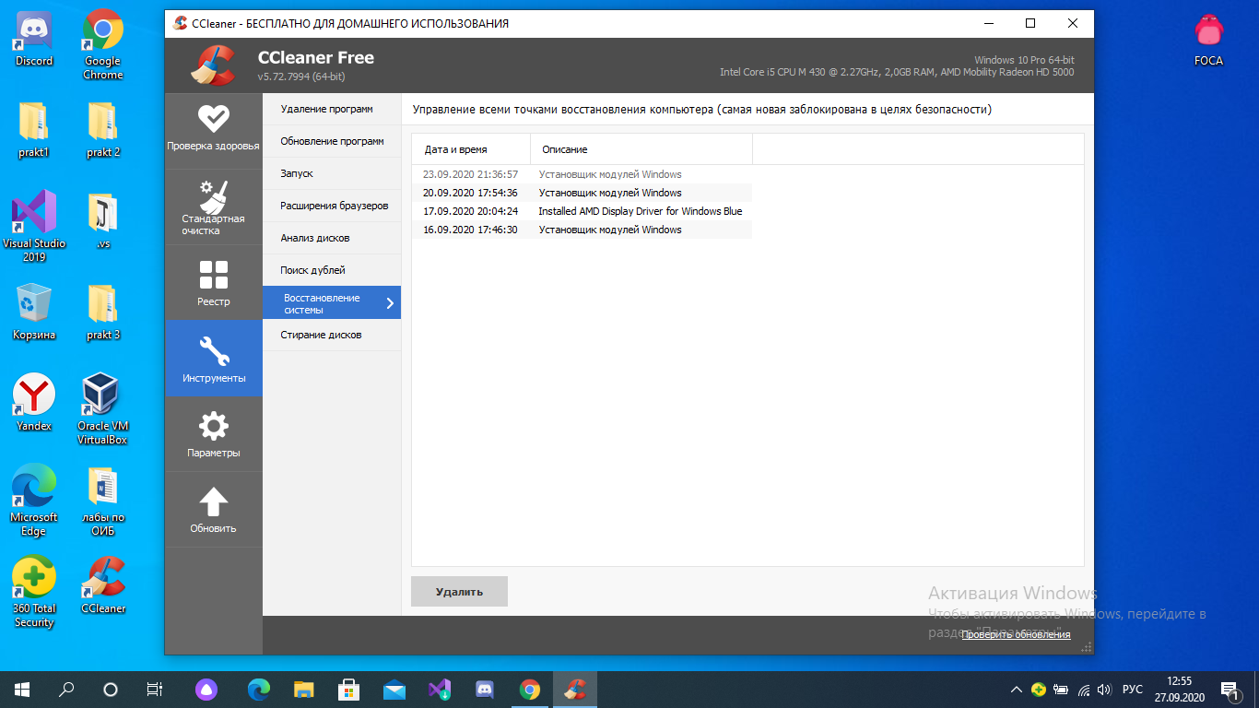

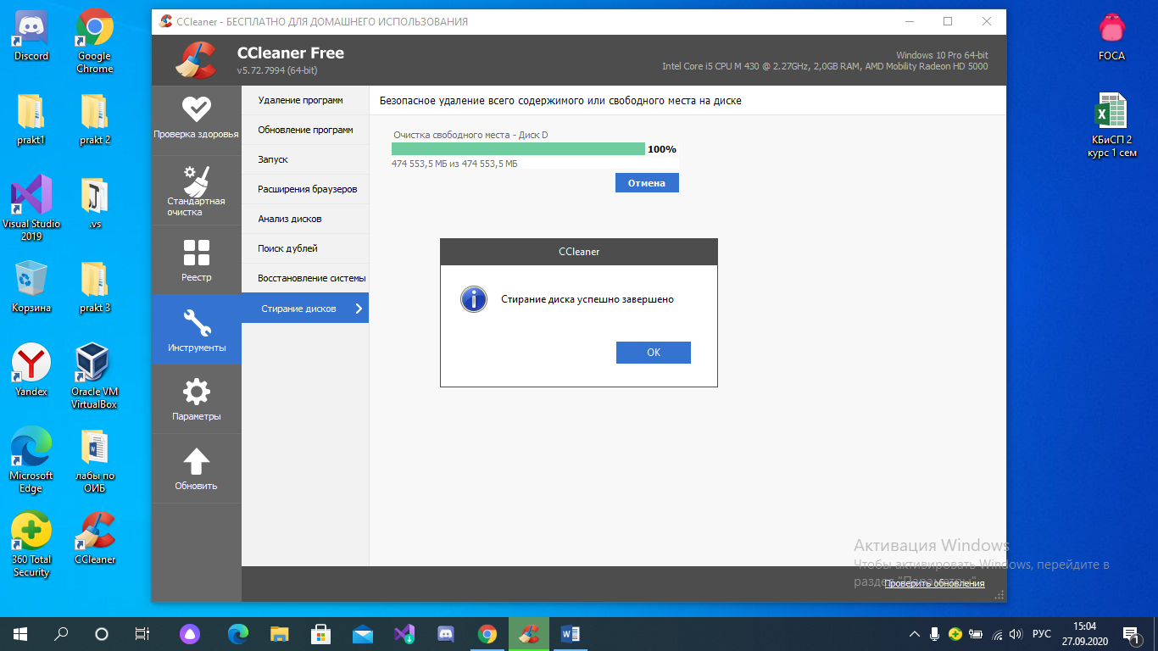

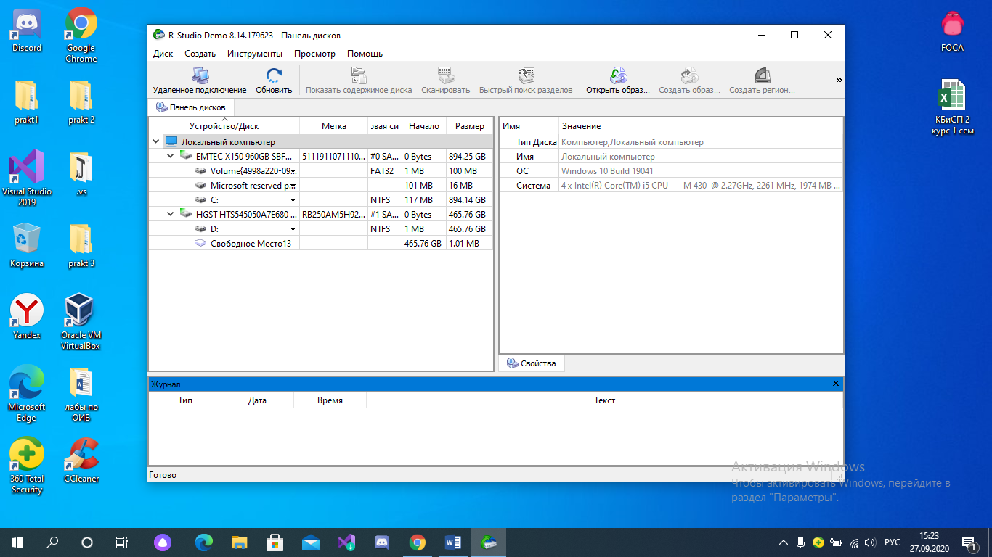

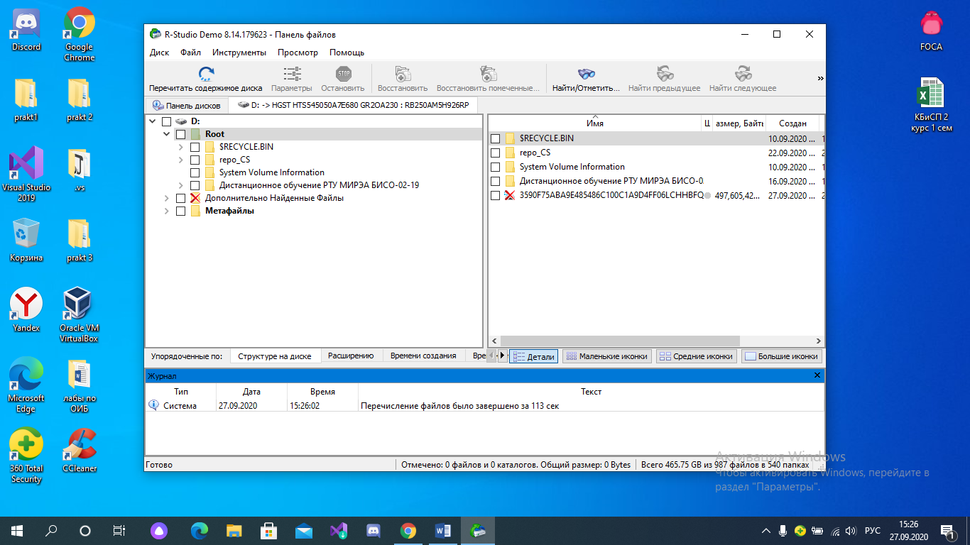

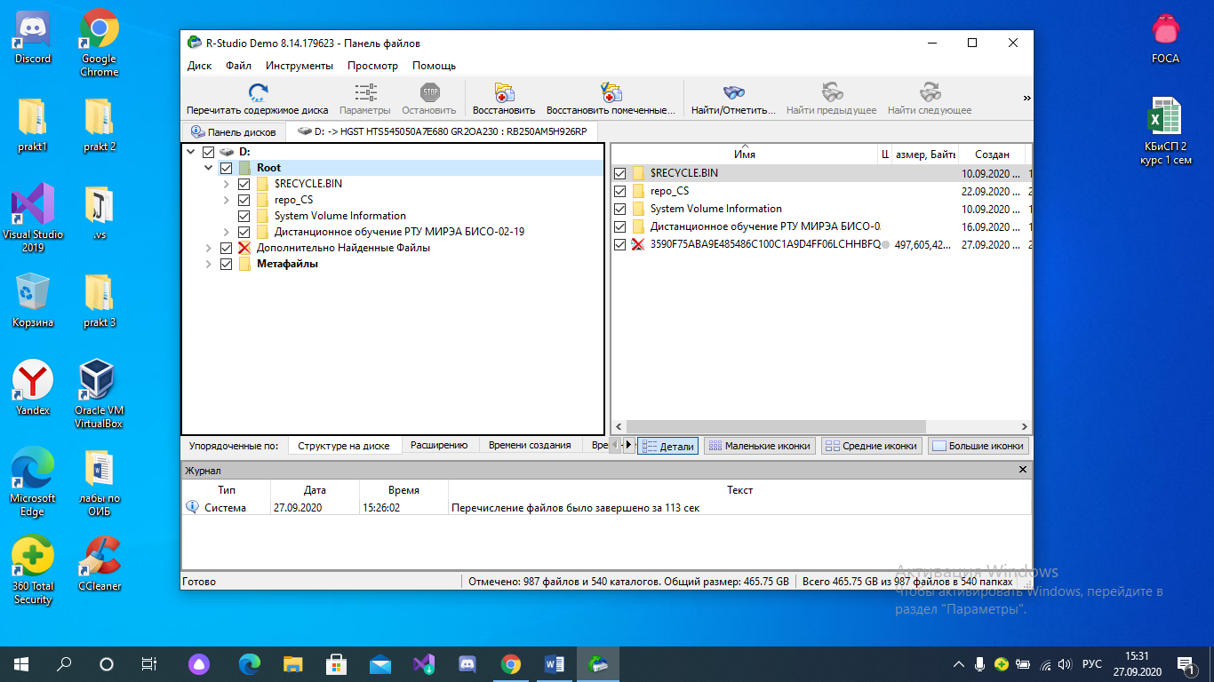

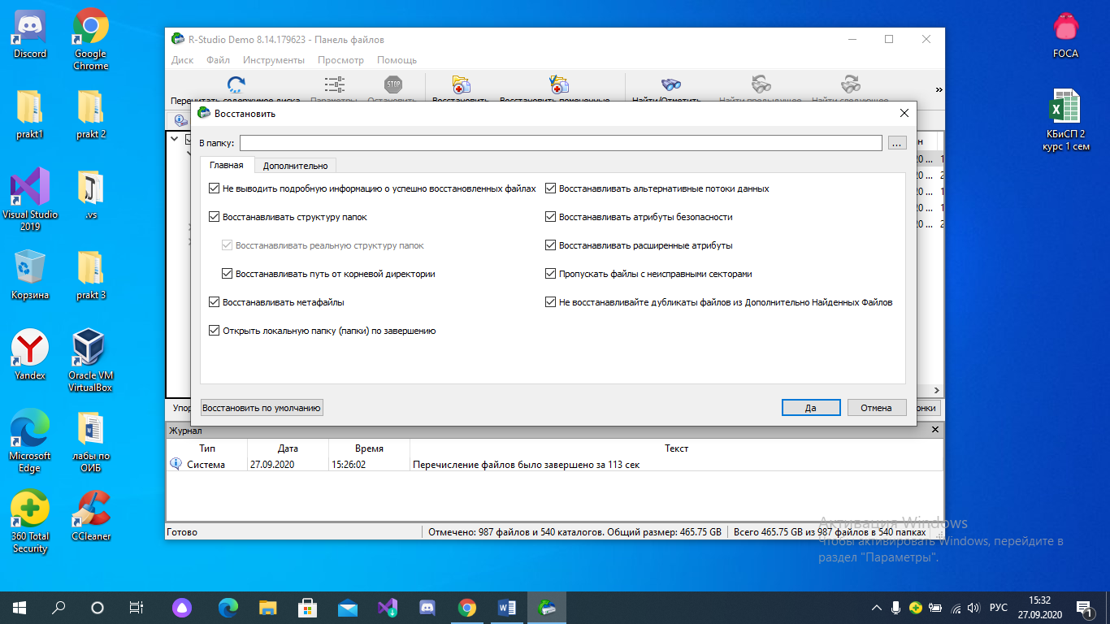после восстановления